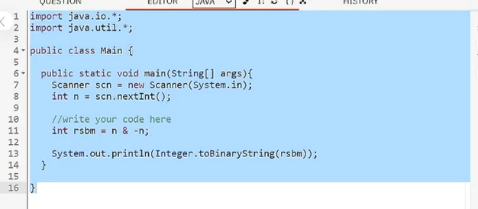
Q2: Right most set bit of a no. say 58:

